**Lab 05 - Implement Intersite Connectivity**

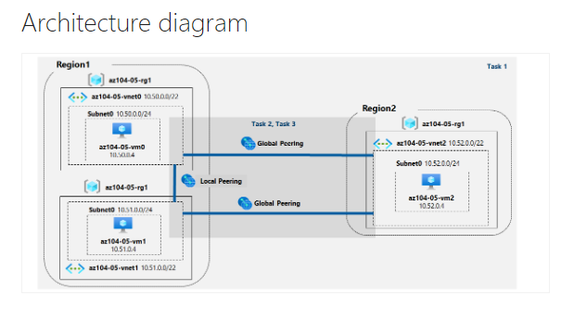

* Task 1: Provision the lab environment.
  + In this task, you will deploy three virtual machines, each into a separate virtual network, with two of them in the same Azure region and the third one in another Azure region.

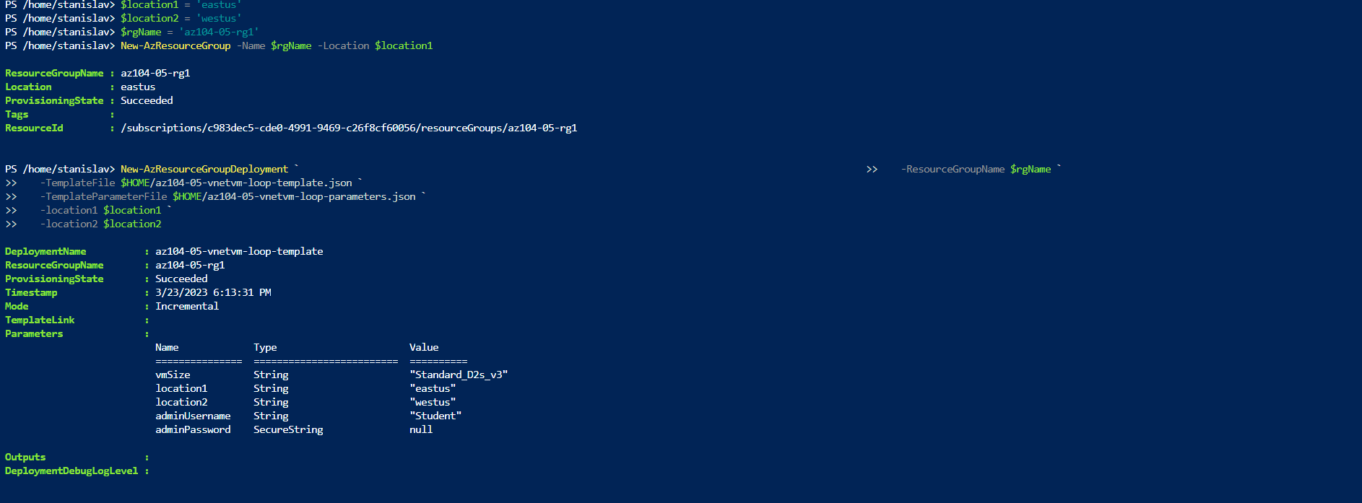

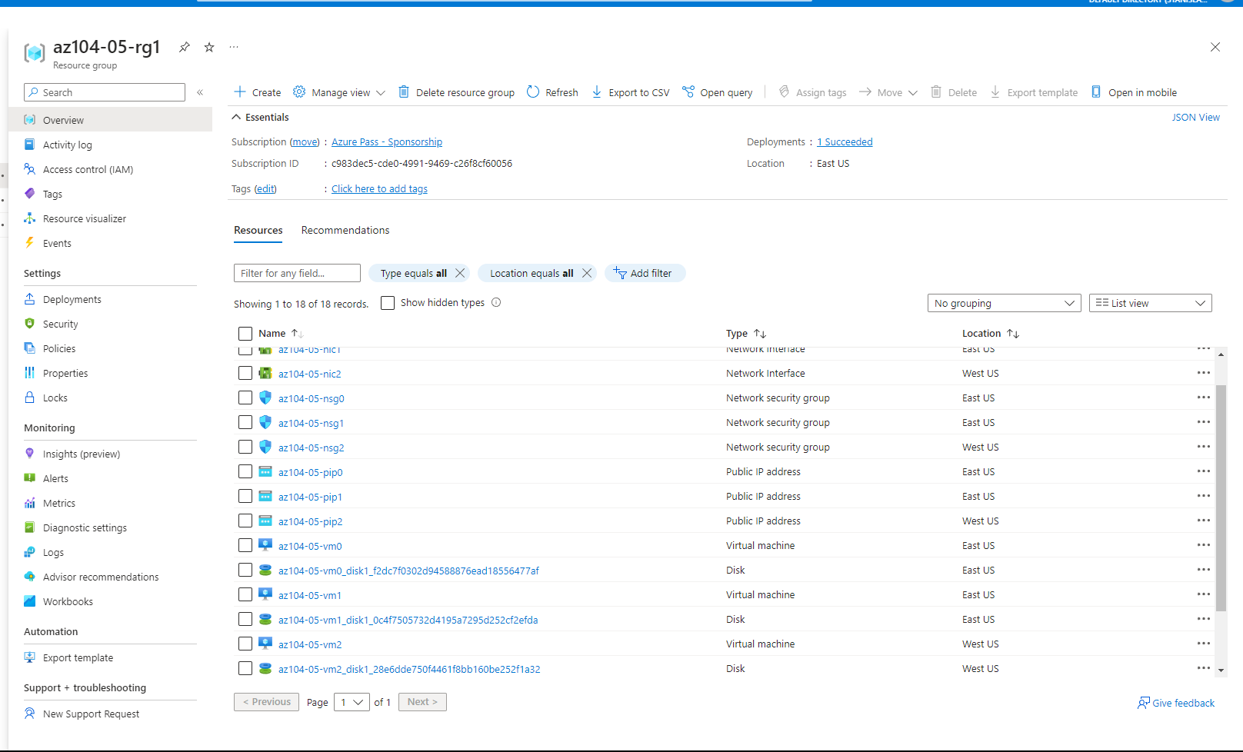

* Task 2: Configure local and global virtual network peering.
  + In this task, you will configure local and global peering between the virtual networks you deployed in the previous tasks.

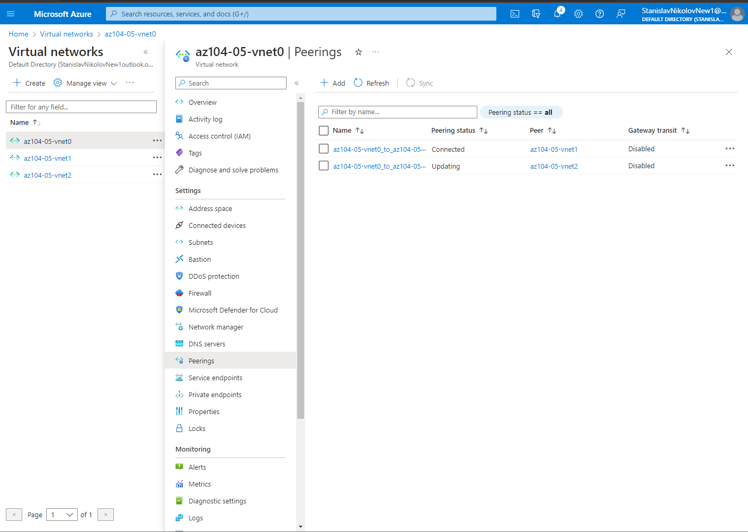

Creating a peering for from vnet0 to vnet1 and from vnet0 to vnet2.

* Task 3: Test intersite connectivity.
  + In this task, you will test connectivity between virtual machines on the three virtual networks that you connected via local and global peering in the previous task.

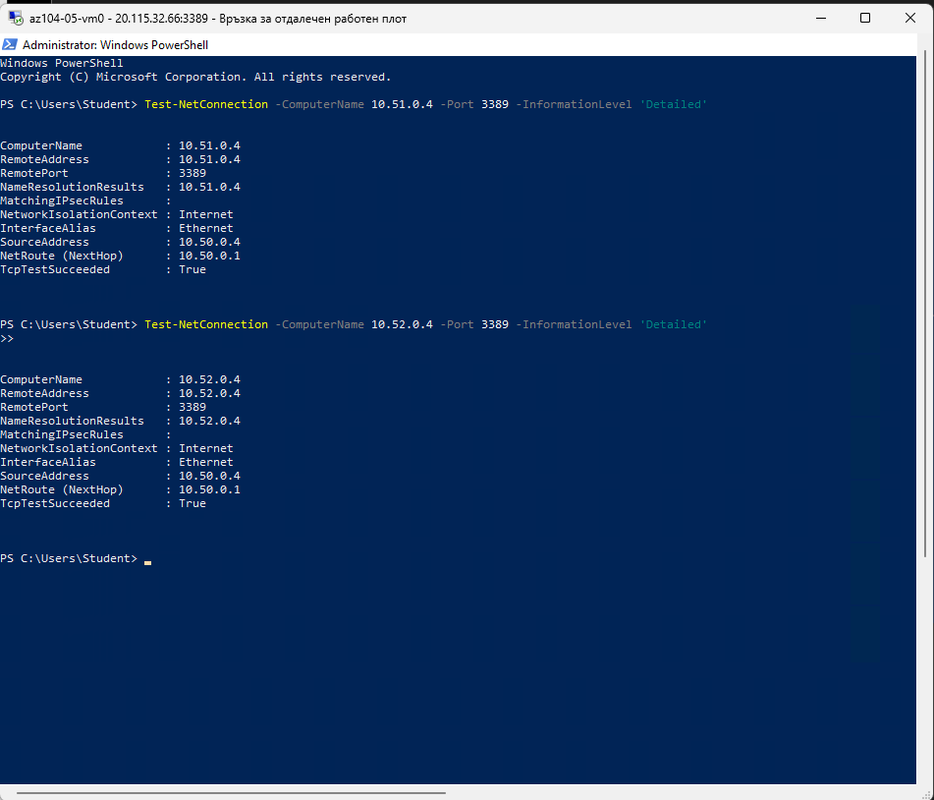

* + In the Windows PowerShell console window from the vm0, we are running the following to test connectivity to az104-05-vm1 and vm2.

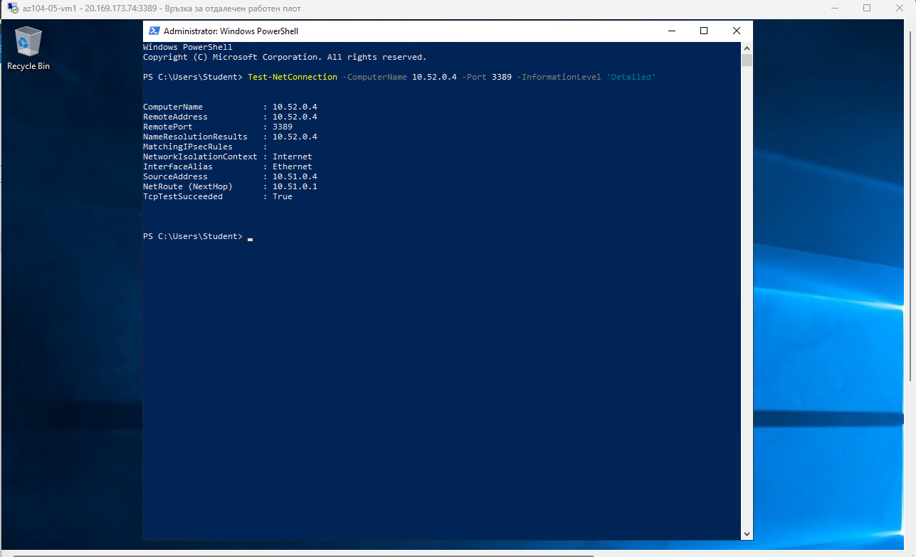

* + In the Windows PowerShell console window from the vm1, we are running the following to test connectivity to az104-05-vm2.